*PROGRAM*

#include<stdio.h>

#define pi 3.14

struct Square

{

float side;

};

struct Right_angled_triangle

{

float base;

float height;

struct Square s;

};

struct Circle

{

float radius;

struct Right_angled_triangle r;

};

float square(float);

float right_angled_triangle(float,float);

float circle(float);

void main()

{

struct Circle c;

printf("\nEnter the side of square:-");

scanf("%f",&c.r.s.side);

printf("\nEnter the base of triangle:-");

scanf("%f",&c.r.base);

printf("\nEnter the height of triangle:-");

scanf("%f",&c.r.height);

printf("\nEnter the radius of circle:-");

scanf("%f",&c.radius);

float a=square(c.r.s.side);

float b=right_angled_triangle(c.r.base,c.r.height);

float d=circle(c.radius);

printf("\n\nArea of square is %f.",a);

printf("\n\nArea of Right angled triangle is %f.",b);

printf("\n\nArea of circle is %f.\n",d);

}

float square(float side)

{

float area;

area=side*side;

return area;

}

float right_angled_triangle(float base,float height)

{

float area;

area=(base*height)/2;

return area;

}

float circle(float radius)

{

float area;

area=pi*radius*radius;

return area;

}

*OUTPUT 1:-*

O 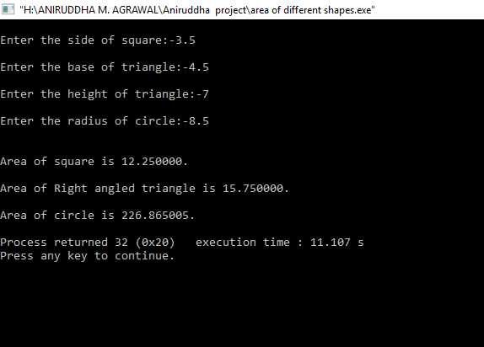

*OUTPUT 2:-*

O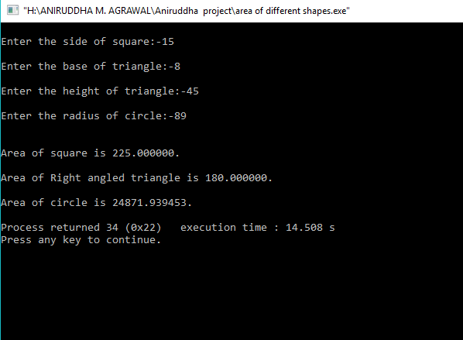

*OUTPUT 3:-*

